

Training in Al-Ain Distribution Company AADC


Final Report Submitted for Partial Fulfillment of the B.Sc. Degree in Electrical Engineering
By

Hamad Mohammed Ali ALSaadi 201010114 Submission Date: 4/1/2015

Fall 2014-2015

Acknowledgments

As I begin my reports, I would like to say thanks for everyone that has helped me reach to the training course or for the people who have contributed to making me qualify to take training course starting by my training advisor Dr. Mousa hussain for leading us during 16 weeks of training, guide us and even visit us in the company and ask us if we faced any problem during my training. I also appreciate the efforts of all the members of ALAin Distribution Company for giving their time and sharing with us their experience not only during the training course but their door are always open for the students. Special acknowledgements go to Training and Graduation Projects Unit in UAE University which is headed by Dr. Sameera and her team (Dr. Mustafa extra…..). Thanks to Hessa I will never forget her rule for being with us from one whole year not one course and follow us from the starting point to complete requested paper. In conclusion I would like to thank the Members of the University who gave me the courage and strength to represent the university in one of the most important companies in the UAE.

Executive Summary:

It was a sixteen weeks training corse and it begun on the 7th of September and ended on the 25th of December. In these 16 weeks I was able to move through two basis directorates and one division. Project Delivery Division: four weeks were spent in this division from 7/9/2014 to 30/9/2014. Project Delivery Division are responsible for executing Power & Water projects and follow with the contractor step by step until closing of the project.
Asset directorate: phase two was in the asset directorate. The next four week in my training course were sent in the Asset directorate which begun on 6/10/2014 up to 30/10/2014. It is inclusive of three departments and these departments are aimed on the company's asset, updating all the new developments in the system, record it in the company's archive and planning for the coming years.
Electricity operation and maintenance directorate: here, I spent the last 8 weeks. The directorate begun from 2/11/2014 to 25/12/2014. It is in the directorate where the maintenance of all equipments in the ALAin network until equipments need to be repaired and replaced so they distribute maintenance on the different departments:
The Operation and Maintenance Department: the department took three weeks from 2/11/2014 to 20/11/2014 which included 4 sections. The Cable sections for cables maintenance and specify the fault location. OHL section which is responsible for the maintenance of all the equipments that related to the OHL pole, insulators and switches. Substation maintenance section is responsible about maintenance of most of the equipments in the substations such as transformers and CB. The Operation section is responsible for the isolation of the fault for previous sections and restores the supply to the customers at the end.
Field service department is made up of two sections street lighting section and VIP section. The governmental property is served by this department starting from palaces, hospitals extra.. Two weeks of my time ere spent in this department.
Network management division: Two weeks were spent in this division, it is responsible to monitor the power network and control it remotely

List of Tables and | Charts
Table Or Chart | Description | Page
Chart 1.1 | AADC Organizational chart | 2
Chart 2.1.1 | Project life Cycle | 4
Chart 2.2.1 | Asset organizational structure | 12
Chart 2.3.1 | EOMD organizational structure | 16
Table 2.3.1 | Type of the Cables | 20
Chart 2.3.2 | NMD organizational structure | 29
List of Figures
Figure | Description | Page
Figure 2.1.1 | Standard of any project |  | 5
Figure 2.1.2 | New development |  | 5
Figure 2.1.3 | Grid station,33KVswitch gear |  | 7
Figure 2.1.4 | Brick built & Its structure |  | 7
Figure 2.1.5 | Package Unit & its structure |  | 7
Figure 2.1.6 | GMT with FP |  | 8
Figure 2.1.7 | Check the Coordination |  | 8
Figure 2.1.8 | Distance between 11KV cables |  | 9
Figure 2.1.9 | Cement Pieces to protect cable |  | 9
Figure 2.1.10 | Warning plastic tap |  | 9
Figure 2.1.11 | Warning fixed cement piece |  | 9
Figure 2.1.12 | Water Pipe |  | 10
Figure 2.2.1 | Serial number of TR |  | 14
Figure 2.2.2 | Material in the Store |  | 15
Figure 2.3.1 | GIS System |  | 17
Figure 2.3.2 | SFT request |  | 17
Figure 2.3.3 | Burn process |  | 17
Figure 2.3.4 | TDR Screen |  | 18
Figure 2.3.5 | Person with dig headphone |  | 18
Figure 2.3.6 | Fault of the cable |  | 18
Figure 2.3.7 | More than one cable in trench |  | 18
Figure 2.3.8 | Sender device |  | 19
Figure 2.3.9 | Receiver device |  | 19

List of Figures (2)
Figure 2.3.10 | Locator device | 20
Figure 2.3.11 | Spick gun | 20
Figure 2.3.12 | Cable Component | 20
Figure 2.3.13 | warning signs | 23
Figure 2.3.14 | Lock | 23
Figure 2.3.15 | Filling the Transformer | 25
Figure 2.3.16 | Fill CB | 25
Figure 2.3.17 | Control Cabinet | 27
Figure 2.3.18 | 1000 W light | 27
Figure 2.3.19 | Diesel Generator | 27
Figure 2.3.20 | RTU | 30
Figure 2.3.21 | Fiber Optic Cable | 30
Figure 2.3.22 | Control center screen | 32
Figure A.1 | Record measurements | 36
Figure A.2 | Opens TR from inside | 36
Figure A.3 | Measure HV phase with LV phase | 36
Figure A.4 | Manufacture of TR | 36
Figure B.1 | PMT | 37
Figure B.2 | Pin insulator | 37
Figure B.3 | Master Head Switch | 37
Figure B.4 | Auto-recloser | 37
Figure C.1 | TRM | 38
Figure C.2 | RMU Feeder Type | 38
Figure C.3 | Drawing of Bus Riser | 38
Figure C.4 | Drawing of Bus Coupler | 38

Nomenclature

AADC | Al-Ain Distribution Company | CB | Circuit Breaker
HV | High Voltage 33 KV | TDR | Time Domain Reflect meter
LV | Low Voltage 415 V | RTU | Remote Terminal Unit
OHL | Over Head Line | SCADA | Supervisory Control And Data Acquisition
PMT | Pole Mount Transformer | NOP | Normal Open Point
GMT | Ground Mount Transformer | TMT | Technical Management Team
TR | Transformer | PMT 2 | Project Management Team
BB | Brick Build | CBM | Conditional Base Maintenance
PU | Package Unit | RBM | Reliability Center maintenance
TRM | Tri Ring Main Unit | CM | Corrective Maintenance
QRM | Quadratic Ring Main Unit | CC | Control Cabinet
DB | Distribution Board | ST | Service Turret
FP | Feeder Pillar | SCMS | SCADA Control Management System
VT | Voltage Transformer | AMD | Asset Management Directorate
CT | Current Transformer | LOA | Issue Letter of Award
VMS | Vertical Mounted Switch | SFT | Sanction For Test
RE | Re enforcement | NMD | Network Management Division
MHS | Master Head Switch | FOC | Fiber Optic Cable
GIS | Geographical Information System | UPS | Un Interrupted power supply

Table of content:

Content Page
Acknowledgments I
Executive Summary II
List of tables & List of figures III
Nomenclature V
Chapter One: 1.1. Introduction 1
Chapter Two: 2. Tasks & Assignments 3
2.1. Project division: 3
2.1.1 Power Project Department 5
2.1.1 Water Project Department 10
2.13. Planning & Control Section 10
: 2.2 Asset management directorate: 11
2.2.1 Planning Network planning and development 12
department:
2.2.2 Asset Performance Department: 14
2.2.3 Asset information department: 15
2.3 Electricity Operation & Maintenance Directorate 16
2.3.1O&M Department: 16
2.3.1.1 Cables section 17
2.3.1.2. Over Head Line (OHL) Section 21
      - Operation section 23
      - Maintenance section 24
      - Planning Section 26
    - Field services department 26
2.3.2.1 Street light Section 26
2.3.2.2 VIP Section 27
2.3.2 Network Management Division ( NMD ): 29
2.3.2.1. SCADA Support Department: 30
      - Operation planning and studies department 31
      - Network Operation Department 32
Chapter Three: Proposal For A Graduation Project 33
Chapter Four: Conclusions & Recommendations 34
References 35
Appendix A 36
Appendix B 37
Appendix C 38

Chapter One

Introduction:

AADC Overview

AADC Overview

ALAin Distribution Company (AADC) is owned by Abu Dhabi Water and Electricity Authority. AADC started in January 1999 according to law number 2 that issued in 1998. AADC gets an yearly budget of AED Billion 1,530,000,000 through Abu Dhabi Water and Electricity Authority (ADWEA) which are funded by executive council of Abu Dhabi Emirate which means that AADC is a government Company. The main office of AADC is located in the middle of ALAin city.The main aim lies in distribution of water and electricity which mean that the city receive Water and Electricity from the TRANSCO which is responsible for Transmission and give it to the end users "people, factories and farm ext….." within the specified limits of its geographical scope specific regions which start from North of ALAin City from "ALFaqah" to South "Um ALzomol " and from west region which start from ALQazna to east region knowing that the water system along more than 3,000 kilometers and up to the power grid along the 16817 km but now more projects and development programs are establishing which mean that network become huge and keep extending. AADC is responsible for and maintenance of the water and electricity distribution network assets, meter reading, and services for the supply of water and electricity. At the end of 2012 the number of AADC employees was more than 1934 and the Company provides services to a population of the East Region of Abu Dhabi (Al Ain Region) approaching one half million people which have direct communication with the society and people not like generation and transmission companies. The best technology systems and equipment are being used in the company in order to provide the best services and the most convenient ways, as well as the establishment of a special quality system and All of this comes to earn customer satisfaction first ,to Realizing

the vision of Abu Dhabi 2021 and in solidarity with other government agencies and to be among the best companies of distribution in the middle east.

  - Organizational Chart of AADC :

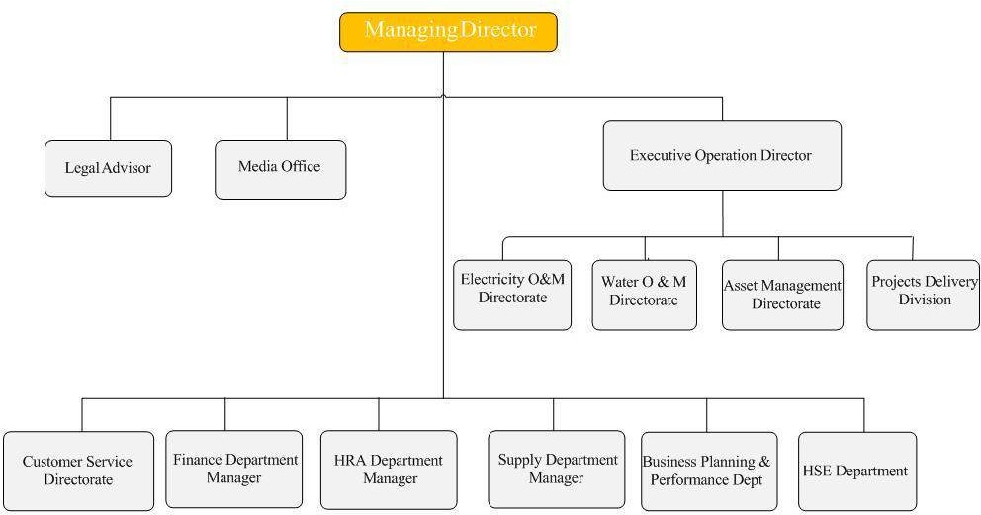
Chart 1.1 AADC Organizational chart

The AADC Organizational structure is well summarized and shown in the Chart above (Chart 1.1). The Departments and places that were assigned for the Tanning course is highlighted with stare

Chapter 2

In details, this chapter will discuss all directorates and divisions that I visited during my training course. The structure charts for each department will be shown in this chapter. Also, some statistics will be included that indicates some problem in AADC itself. In summation to that, the chapter will explain all the required information during my training course and show the difference in the student before the training and after the training is complete. This chapter is the most important chapter in this report.

Projects Division

All the works from Asset directorate come to this division and it is transferred from the schemes and papers to tangible building. Projects division are responsible for Effectiveness of the all equipments in the duration of the project and also within the warranty period as specified in the contract and they keep monitoring the contractor while he works. All Engineers in Projects Division are expected to be experts and trained well to know how to interact with Contractors and consultative. As summary duties and responsibilities of this division are supervision of the new assets, performance of the projects with regard to the assigned standards, and staying up to date with the warranty of the project to make any Adjustments so they work as linked point between asset and Operation & maintenance.
This Division consists of two departments and one section:

Power Project department
    - Water Project department
    - Planning & Control Section
It is important to initially define the Project which indicates group of activities they should give a unique output and it should done in temporary period of time while the program is couple of projects they share at the same goal. There are three factors that have a direct effect in the Project:
- Client: Owner of the Project and he is the one who financed the Project
- Consultative: Representative of the client and his presence is not necessary
- Contractor: Main job is to execute scope of work.
There are three Types of the projects in AADC. First; there are projects that done by AADC and they are the client and contractor in the same time but if there is any

delay they are responsible about that. Secondly; there is the type of the projects called developer projects and are widespread. Developer project are responsible for clients in the municipality as well as deal with governmental companies such as Musanada and Tomoh and they will arrive to an agreement with AADC about the payment at the end of the project because all of the factors are governmental agency. Finally, there are those projects which are suggested by some client not necessary governmental then AADC will hire one contractor form their vender list that’s should follow their specification and they will let him to do the project.
Whatever was the project in the electricity or water sector it should follow approximately the same procedure from starting point until Final acceptance of the project. These procedures divided into five main stages that are shown below:
Initiation
Planning
Tendering
Execution
Close-Out

Chart 2.1.1 Project life cycle
*These five stages are known as project life cycle and they are known as project implementation stages and we will explain each one of them.
Activities done in the initiation phase are mainly they are responsible for Preparation of Project Budget as a request from the owner, collection of business case requirement, study the project very well, what are the goal of this project and they will estimate the primary subject. Secondly, Consolidation of Project Budget, Submission of the Budget Request to ADWEA ,Revision of Budget by ADWEA before the final approval then Approval from Board of ADWEA (Budget Approved) and finally Forming TMT. Thirdly, Tendering Phase which Known also as Awarding Phase. There are a number of activities in this phase starting by Submission to the Tender Committee, Tender Committee Award Decision, Issue Letter of Award (LOA), Successful Bidder (consultant) Acceptance of LOA, Post Award Meeting then Contract Agreement. Then project moving to a new phase which the most important phase from the perspective of the projects department called execution. As beginning they start to form PMT, Monitor , Site Hand Over, Project Payments and Finance issues, Project Risk Management and Finally they are doing all the documents that related to the project.


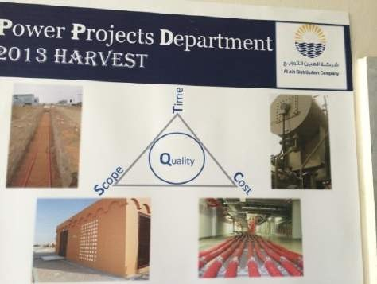
Termination of the project including five important steps starting by closeout, primary acceptance certificate & snag clearance, as-built drawings, material reconciliation, acceptance certificate and finally warranty. Any project should satisfy three things as shown in the figure 2.1.1. AADC adopt the projects in two areas Electricity and Water. We will discuss each department a lone but still all the procedures above apply on both of them.
Fig 2.1.1 standard of any project

Power Project Department


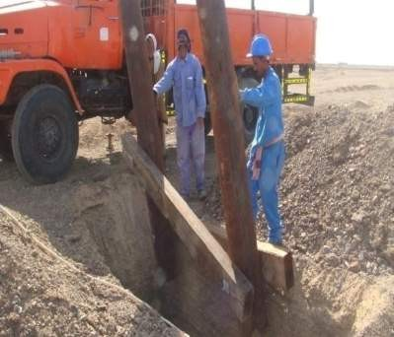
The main Responsibility of the department is for the implementation of all electricity schemes concerning the development of the electricity network in ALAin city, starting from the construction of all types of stations which less than 33KV, laying cables and overhead lines, and this is known as new development
as shown in figure 2.1.2.

Fig 2.1.2 New development

Reinforcement "RE" is also present for the network, such as the replacement of a large number of equipments such as "Transformers, Circuit Breaker …." And this requires that award contracts for the supply and installation of this equipment. In addition to that renovating an old building of the stations is also kind of reinforcement. In this department, their main responsibility start from third and fourth phase of project life cycle which was execution, but they follow up with the asset in tendering stage but they are not the leader of the team. When the first equipment installed on the ground it turn from TMT "Technical Management Team" to PMT "Project Management Team"

then they keep checking and observing the project until completely finish then they close out the project so mainly in this department 3 stages of the project life cycle were done and the contents of each stages were explained and mentioned above*. Main intention of the Power Project department is that the contractor should not go out of the scope of work, cost and specified time and all of these should be clear in any contract. In all the projects there is project engineer and the site engineer. But in large or VIP projects it should be senior project engineer who supervise the project.

Project Engineer
  - Interpretation of the project documents
  - Following up the progress
  - Quality assurance & control
  - Performance assurance & control
  - Approvals (Material, Drawing...etc)

Site Engineer:
  - Ensure site works are as per the specs. (Quality, Quantity & Safety wise)
  - Shop drawing review
  - Reviewing the measurement sheets
  - Participating in the initial & final handing over
  - Inspecting material delivered to site
- Stations Types & Construction

The Primary Distribution stations were constructed by Power Project department in AADC. The primary distributors follow all standards that in the contracts such as the ground of the station, quality of the cables and arrangement of the equipments inside the stations. The Site engineer monitored all the progress of the work. In addition to that, construction of any station should do within the time stage by stage. Power Project department receive the order form Asset then they applied on the ground and they keep in contact with the contractor until warranty period finish then they handover the stations to Operation and Maintenance department.

There are three types of stations:

- Grid Station:


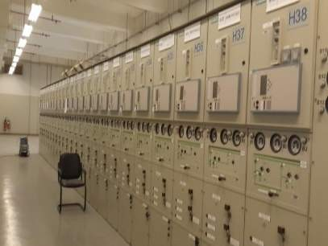
Grid Station consists of: 220/33KV, 80, 90,100&140 MVA Power Transformer, 220 & 33KV Switchgears: (Double bus bar, CB, Isolator, Bus section, Bus Raiser & Bus coupler), Protection Relay, DC system & batteries,
Fig 2.1.3 Grid station, 33KVswitch gear
Capacitor bank, Auxiliary transformer, SCMS System, Firefighting system and but it's construction done by TRANSCO not AADC Project department . Power project department is responsible only about 33KV switch gear as shown in figure 2.1.3 which considers the linked point with TRANSCO checked by Site Engineer in AADC.
- Primary Station:


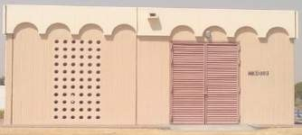

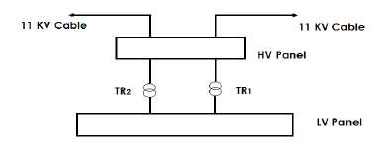
Primary Station consists of: 33/11KV, 20, 15,10,7.5&5 MVA Power Transformer, 33&11KV Switchgears: (single bus bar, CB, Isolator, Bus section & bus raiser), Protection Relay, DC system & Batteries, Capacitor Bank, Auxiliary Transformer, SCMS system, Firefighting System. There are two types of Primary Station. Firstly, Brick Built (BB): The numbers of Power Transformers are two. Secondly, Package Unit (PU): The number of Power Transformers is one.
Fig 2.1.4 Brick built & its structure

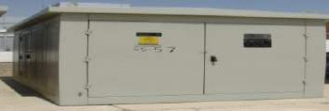

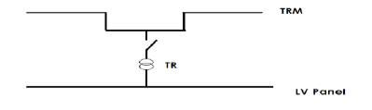

Fig 2.1.5 Package Unit & its structure

- Distribution Sub-Station:

Distribution Station steps down the voltage from 11 KV to 0.415 KV. The types of Distribution Sub-Station are shown in the following:
- Brick Built (BB): consists of electrical equipment located in a brick or concrete building that includes 600 Amp. The equipment are H.V & L.V Panel and two transformers of size 1000 KVA or 1500 KVA.

- Package Unit (PU): includes TRM, L.V Panel with fuses and transformer of size 500 KVA or 1000 KVA or 1500 KVA.

- Ground Mounted Transformer without Feeder Pillar (FP).

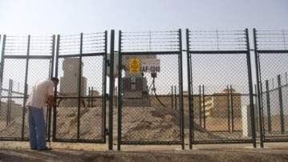
- Ground Mounted Transformer with FP: the FP depends on the size of transformer as follow:
Fig 2.1.6 GMT with FP

- Transformer of size 500 KVA has 1 FP.
- Transformer of size 1000 KVA has 2 FPs.
- Transformer of size 1500 KVA has 3 FPs.

Laying cables


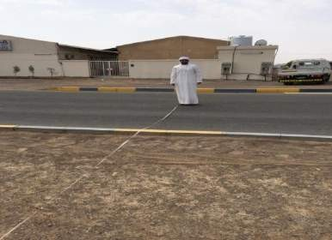
There are strategies that are followed by Engineers for laying of cables. Site engineer Assisted by the consultative should watch the contractor when he extend the cables step by step and observe each step how the contractor do it. The site assistant engineers should take notes and then email it to the project engineer. The following
Steps will explain cables laying. Initially, Site engineer should be sure about the place and trench path as a reference from middle of the street should be exactly the same specified number in the measurement sheet as shown in the figure 2.1.7.

Fig 2.1.7 Check the Coordination

The depth and the distance between the cables in the trench should be verified according cables size. If the cable was 33KV the distance between two cables in one trench should be 50 cm and if it was 11KV cable the distance should 40 cm as shown in figure 2.1.8.

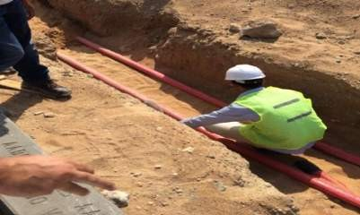

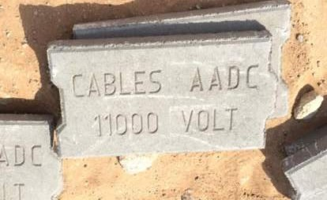
Fig 2.1.8 Distance between 11KV cables
Fig 2.1.9 Cement Pieces to protect cable


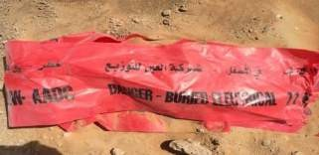
The contractor is responsible for extending the cables in propel way not bend it this is called dressing up cables. Secondly, we should put a layer of net red sand known as du sand as thermal protection to implement the heat. Then they put cement pieces as mechanical protection for the cables as shown in figure 2.1.9. On the concrete pieces there is addition of some du sand for 15 cm. In addition to that a warning is placed on a plastic tape indicates notes on it check figure 2.1.10.
Fig 2.1.10 Warning plastic tap


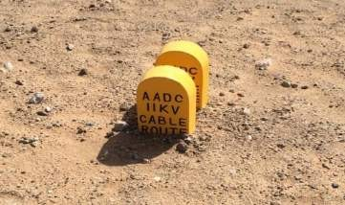
For more protection they 15 cm of du sand. Thirdly, they connect the cables from termination and they do meger test which apply 5000 volt on the cable that show the cable can connect from point A to B. They do also high pressure test which apply 25000 v on the cables to be sure the cable can resist the high voltage. Site engineer should take the reading of Leakage current should be in Micro Ampere and take reading of resistance should be in Giga ohm. Finally,
Fig 2.1.11 Warning fixed cement piece
The trench is closed up and they put a fixed Warning cement piece on the ground that seen by people as shown in figure 2.1.11

9

Water Project Department


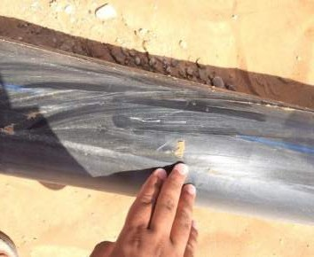
The water department follows the exact procedures of power project department. The department is responsible for monitoring and executing a new project for development of the water network. 90% of their work is laying and extend water pipe and their work is directly related with new project of municipality because they want to ensure access of water to the new homes. Project and site engineers are mandated with same responsibilities and tasks that they have in power department but for water. They do a high pressure
Fig 2.1.12 Water Pipe
test on the water pipe, flush and disinfect the pipe before they receive it from the contractor. Also, it is the duty of the project engineer to review layout that submit it from contractor , also check all the required equipments and make sure that they are in their correct places on the map and on the ground such as Fire extinguisher and valves.

Planning and control Section

The aim of this section starts in the planning stage from project life cycle. Planning section manage documents and transactions that’s transfer from Asset to the power or water project department. It is the duty of the control section to put and adjust some information then they award it to either power or water department but they keep in contact with the project engineer during period of the project not only in the planning stage.
Planning and Control section consists of four units:

- Power control unit
- Water control unit
- Account unit
- Clearance and Documentation unit

I will explain in detail the main duties of this section but I will not talk about water control unit because I did not train with them. After the project award it from Asset directorate their responsibility will start so they do not involve in starting of the project "choosing contractor, total price extra..." . first of all they form TMT "technical management team" and they choose the leader of PMT "project

management team" who should be from project department. Also, they are responsible for the determination of the duration of the project and specify the starting date and completion date of the project. The control section organize meeting called "Post award meeting" which they meet with the contractor and project engineer who are responsible about this project. In addition to that, the planning team prepare a document called "Free issue material" if the contractor will use some of the equipment from the store of AADC. The control team is also responsible for an interview of all the staff that will work with the contractor and they review the C.V for most of them "Forman, electricians". The team is also responsible for monthly report called "Monthly Progress Report" that’s include scope of work, cost of the project ,what are the percentage of completion and always should write the starting date of this project in the report. The submission also of final organization chart that explain this project in details and they who will agree if the contractor submit delay request based on the final organization chart and monthly reports. the account unit is responsible for financial payments of the project departments either water or power. Payments divide into two types. The consultative of the project and this type will divide into two payments either on the design of the project or on supervise on the site of the project. Payments to the contractor and will be either for the equipments (60%, 40%) based on the fast delivery while the civil work will have direct payments not like equipments. Finally, Documentation and Clearance unit is responsible for the assistance of power & water control units to do their charts, statistics and form of any official documents and reports.

2.2 Assets directorate

Assets directorate is responsible for management of the company's assets and we mean by management that managing all the administrative work of the assets including other departments work such as supplying equipments , direct contact with the customers so its reflect the company's business. Also, this directorate is responsible for the representation of the company in the meeting with TRANSCO most of the time. The main aim of the Asset directorate is to make it possible for the supply of the power to the client in the best way and that’s done by improving all the company's assets which is why the provision of electricity which serve the customers at the end. Asset directorate is the one who divide ALAin city into four regions west that’s start from ALyahar to ALKazna, North "from ALFoaa to ALFaqa" , south to um alzomol

and center of the city. Asset directorate manage all the asset in ALAin that belong to 33KV and less so it's responsible about 19 grid stations but not all of the equipment only switch gear, 150 primary stations and around 15000 distribution stations including all the equipments in these huge number of stations. Structure of Asset directorate is shown below:
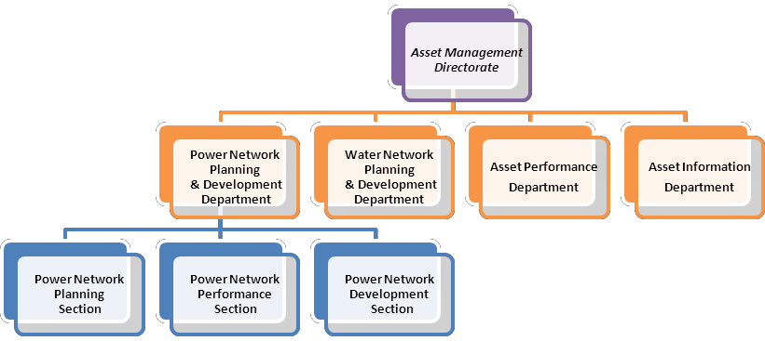

Chart 2.2.1: AMD Organizational
structure

Power Network Planning & Development Department.

Due to the huge network in ALAin city and it's growing by huge different every year so they divide this department in three separate sections and each section will take certain responsibilities and focus on them.

2.2.1.1 Power Network Planning Section

Power Network Planning section is responsible about 33KV network. Firstly, they do an assessment plan every year for next five years at least and keep updating this plan monthly in case there is a sudden case happen of development projects. The planning section are a linked point with transmission company "TRANSCO" and they are responsible for keeping informing Transco every year about their plan for next five years to let TRANSCO prepare if there is huge different in coming years. The power network planning section concentrate on their plan about projects that related to 33KV which mean building new primary stations and that need huge amount of money not like

distribution stations that’s why they plan for next 5 years to specify the budget. When there is a prediction on how much the total load will increase next year's they keep in their mind the total capacity of each primary and they follow rule (N-1) which mean there are three transformers and one of them has a fault then the rest two can take the whole load without any problem. When the planning section designs for their prediction they design with ring system with previous stations not radial system which defined as if there is a fault and the whole primary station come out of the network the load under it can be feed it from other primary. In conclusion, this section has a meeting every couple of months with other governmental agencies if they have new coming projects.

2.2.1.2 Power Network Performance Section

The power network performance section will have similar responsibilities of planning section but with 11Kv and less and they do not have a plan for long time because they deal with distribution stations and with mush lower cost. The section is mandated to receive a request called "Supply Arrangement Request" for electricity supply to the customers. The power network performance system study the request that’s come from customer service directorate if the load 300KW and more only. They see if they can feed the customers from closest distribution station then to feeder panel then to requested house but if they cannot they start to suggest on the customer to have a transformer in his house. The performance section is responsible for dividing the load into two types AC load and other loads such as lights, fans and extra. Also, they calculate the load in KW and they calculate the current by following equation
P = √3 *Vpp*I*COSθ. After that they can find out the cable size by dividing current
on a factor of 1.74 and decide cable size.

2.2.1.3 Power Network Development Section

The duty of power network development section is shared between planning section and project department. They start working at the beginning of project life cycle which means from the second stage which they receive a request from planning section and they start to put scope of work and specification of the project as a first step. The development section enter the third stage "tendering". In the beginning of this stage they start to review a vender list of the factories and they approve the list. In summation to that they approve bender list which the list that shows all the contractors that apply to take this project and also they who approve the list. Thirdly, they start to do their evaluation for

the contractors which divide into two types: Technical evaluation which supervised by this section and they approve the contractors who get 70% and above. Other type is commercial evaluation which about the price and this happens outside this section. Also, they give approval on the price that specified by contractor in the middle of the project if he wants extra money. If the contractor wants to change in the bell of quantity he should communicate with development section only. Finally, they record all the projects that are finish and done form project department in the company's archives.

Asset Performance Department


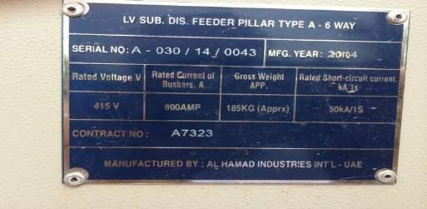
The asset performance department divides into two sections; water section and power section. My training was in the power section only but both of them they follow the same procedures which focusing on the Assets of the company and study them. Assets divide into two types Non Moving Materials and Moving Materials and both of them invested by the company. In the performance departments they concern about Non Moving materials only such as power network and its equipments. There is some information and features of the assets itself placed by performance department such as an "identification number" this
number should be unique for every equipment as shown in figure 2.2.1.

Figure 2.2.1 serial number of Transformer

All assets have an Introductory Certificate that’s explains when the asset was delivered and installed. Performance department study the asset if have a value or just supplied and do not used. Most important thing that, they should specify each location for each asset that related to AADC and records it in the system. The department also monitors the whole network and doing monthly reports

on the network to see the performance of the company based on number of shutdowns in every year. Department works on the analysis and converts information to charts so they can calculate the number of interruption and see which region have more interruption. They look also to the reasons that cause the interruption especially for over head line if its storm, fire or weak protection. This department is concerned about inventory of materials in the store every year as shown in the figure 2.2.2 and they classify wanted equipments to each department. One of the most important tasks in the department is studying the life time cycle for most of the assets by analyzing graph and they used some specific equation to know the performance of this asset like
for transformer: 𝑃𝑒𝑟𝑓𝑜𝑟𝑚𝑎𝑛𝑐𝑒 = ⁴⁰ ^{𝑦𝑒𝑎𝑟𝑠−𝑢𝑠𝑒𝑑} ^{𝐴𝑔𝑒} ∗ 100 and they analyze the
40
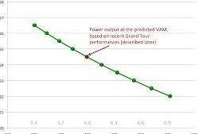

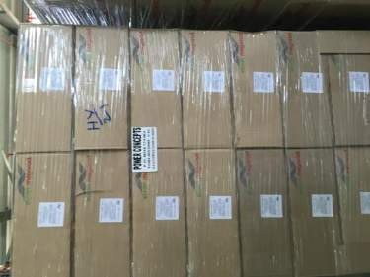
graphs to know life time cycle as shown in a sample graph below:
Figure 2.2.2 Stored Materials

Also, when there is any FAT "Factory acceptance test" to buy any equipment Engineer from this department should to be there and attend the test and accept the equipments. They do the test on 10% of the quantity that will buy. Check Appendix A
Graph 2.2.1

Asset Information Department

Asset information department include is made up of two sections:
      - Asset information section
      - Asset Data management section

The Data management section all the staff and engineers work on a maximo program. They Store and archive the data on system & reviewing the layout. The

order of the steps, Data management section are mandated to finish their work before asset information section because information section they need the data stored in the system so they can work and see the latest update. Moving to the second section "asset information section" which includes two units:
- GIS water
- GIS electricity
The asset information section old maps which designed before year 2000 were editing on the GIS system "Geographical information system". Main job is to keep updating and entre new network specially cables and water pipes. In the GIS system there are all the shapes and symbols that represent "primary stations, TRM, transformers Extra... in GIS so they can also build all of the stations and edit them in GIS.

2.3 Electricity Operation & Maintenance Directorate

Electricity Operation and Maintenance Directorate mainly deals with AADC equipments for long time after the warranty period from project department. They are the responsible of the maintenance for all the equipments until its need to be replaced. Every department or section is responsible about certain device. We stayed around 8 weeks in this directorate. Organizational Structure of Electricity Operation & Maintenance Directorate is shown below:

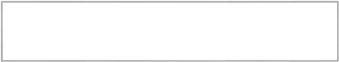






Electricity Operation & Maintence
Directorate
Operation &
Maintence Department
Network
Managment Division
Testing &
Protection Section
Field Service
Department
Northern
Region Section
Southern
Region Section
Western
Region Section

Operation and Maintenance Department
Chart 2.3.1 Organizational Structure of Electricity Operation & Maintenance Directorate
The duty of this department is the maintenance most of the equipments such as all the stations, cables and OHL. Also, they responsible about the operating and shutdown any stations when there is fault happen and they isolate from termination.
O&M department is divided into five sections:

- Cable Section.
- OHL Section.
- Substation Maintenance Section.
- Operation Section.
- Maintenance Planning Section

Cable Section

cable section is very important since most of the network in ALAin is cables so its need very well maintenance, expert engineers, labors for digging and modern equipments to find the fault quickly because its underground around one meter. Their responsibilities start when there is a fault happen to 33, 11 KV, and LV .Operation section will send a request to them to specify the fault location approximately by GIS as shown in figure 2.3.1 so the operation section can isolate the damage cables for them from two termination side from the substations. Cable section asks operation section about SFT "sanction for test" as shown in figure 2.3.2 which mean this cable is safe to work on it. They do this process in either situation fault happen or identification which they consider the main responsibilities of cable sections.

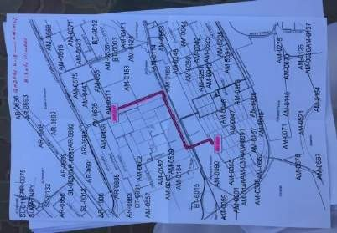

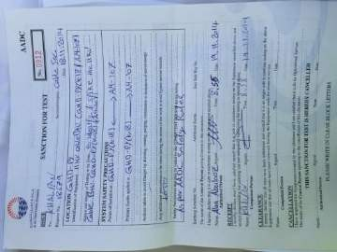

Figure 2.3.1 GIS System
Figure 2.3.2 SFT request

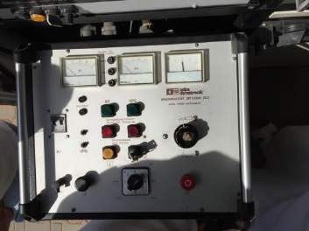
First of all I will explain what are the procedures and steps that follow when the fault happen. They start by doing burn process which help to found which one of the phase is damage. When the engineer start to do burning in the test van for each phase, the damage phase will

17
Figure 2.3.3 Burn process

show increasing in the leakage current and it will show small value of volt as shown in the figure 2.3.3 above.
Second phase is called TDR "Time Domain Rectometer" which show the distance of the fault from your place by meters on a screen and also will show you which one of the phase having the fault as shown in 2.3.4. The most important step when the fault happen is search which means that it will specify the location of the fault exactly by sending a pulse every period of time specified by engineer then he will wear the dig headphone which help him to hear the voice of digging and that voice represents the leakage current when it try to escape as shown in figure 2.3.5. The last step called HPT "high pressure test" and this step done only when the voice not clear especially in HV 33 KV because it's underground too much.

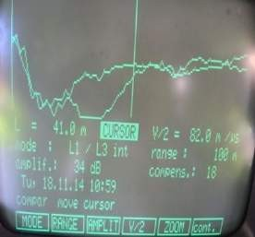

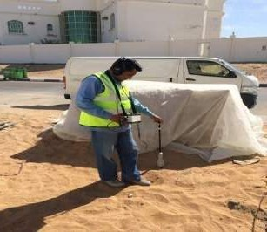

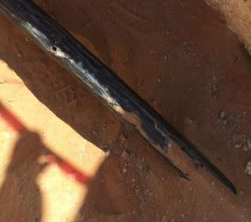

Figure 2.3.4 TDR screen
Figure 2.3.5 Person with a dig headphone
Figure 2.3.6 fault of the cable

Type of fault:

- Join fault
- Manufacture fault "If it's in warranty period they will contact with factory or the contractor who supply them".
- Damage fault which may happen because of one contractor damage it when he want to dig so need to inform the legal affairs then the police.
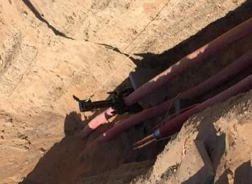
- Termination fault

The other responsibility of the cable section is identification. This is when the contractor wants to build a new substation and he want to take a node from specific cable so he will ask the cable

18
Figure 2.3.7 more than one cable in trench

section to identify to him the cable if there is more than one cable in the trench as shown in figure 2.3.7.
Cable section will follow certain steps to identify the cable:

- Ask the operation section to isolate from termination and sign sanction for test paper
- Fix a sender on the wanted cable in one of the terminals only by putting a red mark in the device on one phase of the cable and black & green to the ground as shown in figure 2.3.8.
- Other terminal in the second substation should be connected to the earth by operation section.

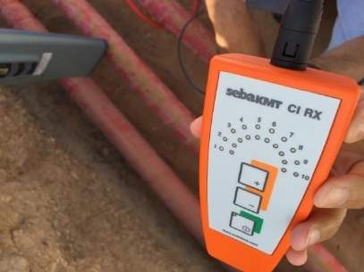
        - Engineer takes the receiver device with him to the site and he put it on the many cables. The signal will be strongest on the wanted cable as shown in figure 2.3.9 and it will indicate two colors red and green. If the receiver in the same direction of the grounded termination the signal will be green otherwise will be red .We can double check by using device called locater and its shows the signal without the direction in figure 2.3.10.
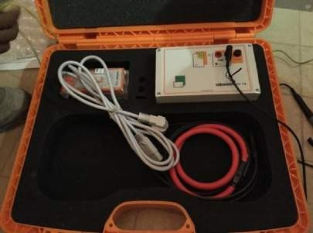
Figure 2.3.8 Sender device
Figure 2.3.9 Receiver device

Identification was done and now the contractor wants to cut the cable to take a node for his connection but that done by cable section only by using spick gun or hydrogen gun in figure 2.3.11 that fix it on the wanted cable then engineer will pull the bullet by long thread then the contractor can cut the cable very well and make his connection.

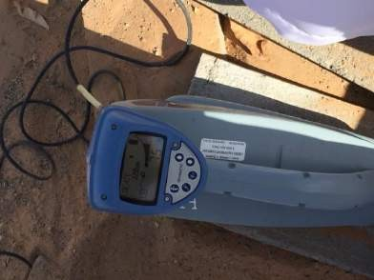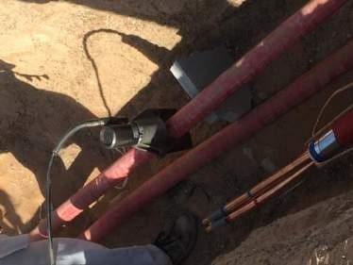
Figure 2.3.10 Locator device
Figure 2.3.11 Spick gun

Main components of the cable:

          - Conductor "which made of copper"

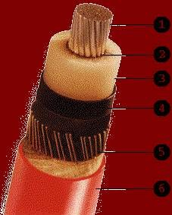
          - Semi-conductor " prevent the electrons of current escape" 3- Insulating material "made from XPLE" cross linked
polyethylene
4- Steel strips as "inner jacket" 5- Stranded wires
6- PVC "Outer Shell made from (Poly-Vinyl-Chloride) Sheath", but before PVC there is armor for mechanical protection which between 5 and 6.

Cables are classified according to specific criteria as follows:
Figure 2.3.12 cable's component

Voltage level | Classification
400 KV, 220 KV, 33 KV | High voltage cable
11 KV to 1000v | Medium voltage cable
Less than 1000 | Low voltage cable

Table 2.3.1
- Current ratings: Cross section area of cables differs with current value directly proportional.

- Insulation Type: Three types of cables are used according to the insulation material: (XLPE and PVC).
- Number of cores: A run of cable may consist of 1, 2, 3, 4, or 5 cores.
- Conductor type: The type of conductor used in cables could be Copper or Aluminum.

OHL Section

The OHL section is responsible of the 33/11KV OHL network in Al Ain city so it's feed to many distribution stations that’s why they specify a special section for it because it consider a second most important source of distribution in the network and as a first transmission way because of the small amount of losses. In AADC they use copper of aluminum conductor and the cross section of the conductor are: 35, 70, 95, 120, and 150 mm². There are around 6000 KM of OHL in ALAin city especially in the external regions that why this section consists of two units:
- Inspection and monitoring unit
- Maintenance unit

Monitoring and inspection unit is mandated to scan over ALAin city especially after the storm they keep patrolling, observe if there are any problems and if they found any problem they reported quickly to maintenance unit but some time there is temporary fault so they will solve it. When maintenance unit receive call or report from inspection unit, they will contact with operation section to isolate the line for them from both terminals of the line, grounded to the earth around 7 m from each side as a safety for them and ask for SFT then they will do their maintenance on the damage equipment or the pole itself.
OHL Components: Check Appendix B

- OHL switches:
The main aim of OHL switches is delivering energy safety, efficiency and reliability.
- VMS: vertical mountain switch
When we have OHL and there and there is any interruption such as street ans we want to complete we use VMS
- VMSF: vertical mountain switch with fuse will have the same purpose but with fuse

- Master Head switch (MHS)
From its name master that mean its control the whole line from pole to pole or it give you a choice to open the line from middle

Auto-re-closer (CT)
Is a circuit breaker prepared with a mechanism that can automatically close the breaker after it has been opened due to a transient fault. It will make several pre- programmed attempts to re-energize the line. If the transient fault has cleared, the auto-re-closer's circuit breaker will remain closed and normal operation of the power line will resume. If the fault is a permanent fault, the auto-recloser will exhaust its pre-programmed attempts to re-energize the line and remain tripped off until manually instructions.

Sectionalize (VT)
It operates when a line is "dead" because of the operation of an auto-re-closer or breaker along the line. Sectionalizes serve to isolate a section of line while allowing the remainder of the circuit to remain energized.

PMT

it is step-down TR. The PMT should have some specification such as TR power 200 KVA

A Lighting Arrestor/ Surge Arrester
Lighting Arrestor is located in the top of the pole. It used to protect the cable and PMT. It consists of insulation (porcelain), bracket and fault indicator.

Pin for 11KV or Post insulator for 33KV
It's made from porcelain or polymer which used as a protection to the pole itself from the fire.

Kicking blocks.
When they start to construct Hpole in new project or replace one of them they use blocks to fix the pole very well under the ground.

Earth Fault Indicator (EFI)

Is designed to indicate the short circuit fault and identify fault location. It accurate fault indication enables the operator to identify the fault sections easily and isolate them in time.

Operation Section

The operation section is the busiest section in O&M department because it is responsible for serving all other sections when they want to do their work. The main duty of this section is to rectify the fault equipment and restore the supply to the customer so they isolate the fault and feed the customers from other substations according to ring system. The fault is identified by a device called earth fault indicator which appear on the door of the stations. When the device lights that mean the fault happens after this substation. Operation section is the controller for all shut down, energize, isolate fault in the network. The main disadvantage for the operation section is to bring back the load as soon as possible in emergency time. This section is made up of two Units: planned shutdown and UN planned "emergency" unit.
- Planned shutdown: planned before such as operate new substation for project or contractor want to do join in the cables or fix something in the station.
- Emergency unit: fault happen in the network "cables, OHL or equipments in the stations" because of fire or storm.
Both of the units follow the same procedures:

- Isolation the fault from both side
- Apply earth from both side
- Put danger signs. Check figure 2.3.13
- Put a lock on the isolated place. Check figure 2.3.14
Fig 2.3.13 warning signs
Fig 2.3.14 Lock

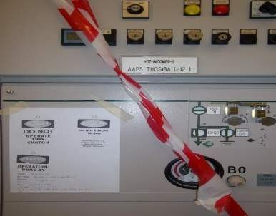
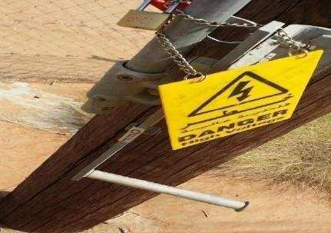
23

- Give safe document which include three types
  - PTW "permit to work". If it was on the earth the other section's engineers or labors cannot remove the earth off.
  - SFT "sanction for test". He can remove the earth but with permission from operation section.
  - LAB "Limit access permit". He can enter the station but without doing anything or just to check simple equipment.

Substation Maintenance Section

The substation maintenance section is responsible about 80% of the equipments in the substation. Substation maintenance section divides their work into Corrective Maintenance "CM", Condition Base Maintenance (CBM) and Reliability Center Maintenance. Corrective maintenance mean emergency that’s mean fault happen in of the equipments that related to this section. Condition Base Maintenance is a group contains engineer, assistant engineer and technicians to do inspections on substations and check the following:
- Circuit Breaker (oil , vacuum and SF6)
- Transformer with whole the equipments ( tap changer, body of the
transformer, its oil and extra…) as shown in the figure 2.3.15
- Silicajel which define as small grains absorb humidity from the body of the transformer it's have two color white or blue, the white when its damage or need replacement change to brown while blue change to pink color.
- Check the whole buttons of LV and HV panels, if some of them need replacement.
If they found something danger they reported to the corrective maintenance as soon as possible but filling oil, refresh circuit breaker and clean the transformer from their specialty as shown in figure 2.3.16.


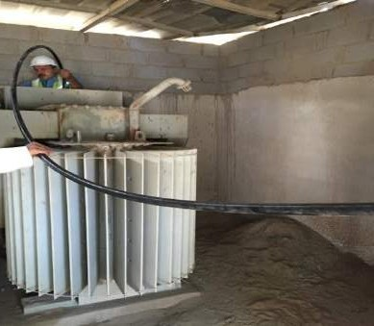

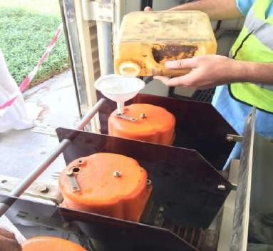
Reliability center maintenance "RCM" collects the information from CM and CBM then they analyze it, study it and finally they put commandments to the section to change the company that supply this type of equipments according to increase number of defects.
Fig 2.3.16 Fill CB
Fig 2.3.15 Filling the Transformer
These section deals with same equipments that do same purpose but each company manufacture it in different way. I will identify related equipments to this section
Type of cooling for the transformer:

- ONAN "oil natural air natural"
- ONAF "oil natural air forced"
- OFAF "oil forced air forced"

Difference between isolator and circuit breaker

- Isolator: when we want to close it or open it , we should do that with the load is off because it does not have a media to extinguish the spark.
- Circuit breaker: we can open it or close it even with the load is connected Difference between bus coupler, bus section and bus riser check Appendix C.
- Bus coupler: connect between two bus bars
- Bus section: connect between two separate piece of bus bar it self
- Bus Riser: complete the connection so if the first load connected on bus bar 1 then I will use bus riser to connect load 2 on bus bar 2.

Maintenance Planning Section
The Maintenance Planning section is developing and scheduling all activities of maintenance for respective sections. All scheduled activities are done after coordinating with Network Operation Department. They organize between all the sections in O&M department if one of the sections needs to do any shutdown what are the effect on other sections.

Field Service Department

The field service department is responsible to serve governmental agencies and ministries such as hospitals, palaces, street lights and any other governmental services. Field service Department have all the equipments that O&M department has except OHL section so they can manage their work alone but also sometimes provide help to other departments to supply the electricity to the customers in emergency time. This department includes two sections:
      - Street light section
      - VIP section

Street light section

The Street light Section is mandated about all the streetlight columns in ALAin city and its external regions. Street light Section is made up of two Units Patrolling & Emergency Unit "accidents of cars, check the damage and Maintenance Unit. Patrolling unit gets reports from DMS and then they transfer it to maintenance unit. There are two types of light used in AADC (high pressure sodium & metal halite) and their brightness {150w, 200w, 600w, 700w, 1000w, 2000w}
        - For Neighborhoods 150 w were used.
        - For highways 1000 & 2000 w were used They have an indication for each color such as :
        - ww for purely white
        - yy for yellow
        - yw between the two color

During my visit to Swehan with engineer, I knew the steps of how the connection is done:
        - Photo cell is programmed at certain time to give an order but there is time difference in the winter and summer so time difference its programmed by engineer
        - Photo cell give an order to the Solar cell then it's give order to the magnetic contactor to open which give an order to the MCCB "main control circuit breaker"
        - One control cabinet it has 8 circuits and every circuit can feed street with long of 30 or 40 meter.


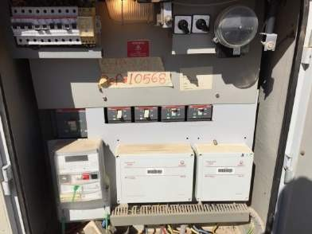

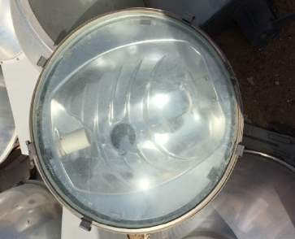
Fig 2.3.17 Control Cabinet
Fig 2.3.18 1000w light

VIP Section

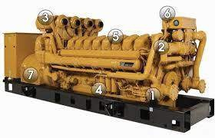
The main responsibility of this VIP section is to secure the supply for sensitive places such as palaces, hospitals and military bases. The VIP section should put in their consideration many ways to secure supply even after the generators crash. The places have fixed generators in the substations but sometimes they used mobile generators which mean is movable generators for emergency case. VIP section
consists of four units:

- Operation Unit
- ALRawda palace Unit
- Maintenance Unit
- Workshop Unit
Fig 2.3.19 Diesel Generator

Operation unit is responsible about isolate the fault when it's happen and restores the supply from the generators. They responsible about inspection and test the generators

if its response when fault happen of not. Also, they operate mobile generators "movable generators" when it's emergency happen.
The power forALRawda is the same power all the three other units have which mean that they have a maintenance team, operation team and mobile generators. Inspection is done and test for the generators every three months because it’s a very important place.
The Maintenance unit which is getting the request from operation unit when they record any strange thing or damage equipments or the generators do not response in normal way. Maintenance unit is responsible about all the palaces, hospitals except ALrawda palace because they have their own team. The fault is divided into three types Mechanical, Electrical and Control & Instrument so they send particular team.
Also, the Workshop unit is very important unit since this section consider a separate section from AADC they have most of the equipments and they do not depend on the other sections so they need a workshop to do some test on the mobile generators to fix them, on Relays and how its response when there is fault happen and on the other equipments.
Type of the generators and how its work:

- Manual generators
  - Engineer should be sure that there is no supply for electricity from other source
  - Convert MTS "Manual Transfer Switch" button from main to off and then put it on the generator mode.
  - Fix frequency and the volt manually and then turn on the generator manually

Semi Automatic

Semi-Automatic Sensing voltage relay is responsible for sensing if there is any change in voltage or frequency and it will activate automatically by sending a signal to LMS "load management system" to trip all outgoing feeders in the substations and then give order to CB of the generators to close then the generators will start. After that Voltage and frequency will be stable after few minute. Generators will feed bus bar and return the outgoing feeders one by

one according to popularity. When the main incomer back to supply, the engineer should switch the MTS to the main supply side then the generators will shut down after 5 minutes.

Full Automatic generators

Full Automatic generators will follow same procedures of semi-automatic generators but it has a switch called ATS "Automatic Transfer Switch" that’s mean no need for switching the MTS manually when the main incomer back to supply the substation because it will transfer the load automatically by ATS. There is a system called Full Automatic with back synchronizing. The customers will not feel the shutdown when the main incomer back to the service because the generators and main supply they will share the load until main incomer take all of it. there is an interruption of electricity happen when the generator start to work and that can be a void it by UPS system which define as a storage of the DC then its converted to AC by device called inverter but it works for specific time only. Reasons of providing these two systems patients in the hospitals who cannot breathing without electrical equipments even for seconds or when the doctors make an operation.

Network Management Division

This Division with all departments is responsible about monitoring the network and detect if there is anything that is unusual in the net work which include all the primary and distribution substations. They monitor load, frequency, transformer and every single equipment in the network so they distribute their work among many departments. The structure of this division is shown below:

NMD
SCADA
Department
Operation
Planning
&studies
Software
section
Hardware
Section
Telecommunication
section
Network
Opration
Depaertment
Development
section
Operation
planning section
Operation
studies section
29
Control center section
Chart 2.3.1 NMD organizational structure

SCADA Department
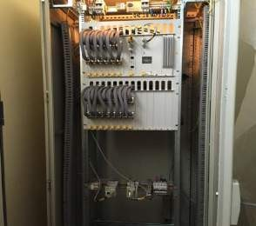
SCADA stand for supervisory control And Data Acquisition

Hardware Section
Hardware section is responsible of transducers (analog input for RTU) , command relays ( digital output for RTU ) and status relays ( digital input for RTU ) and RTU itself .
Fig 2.3.20 RTU
RTU will collect all the information from these devices which they define as follow: Transducer: analog input device locate it always after CT and VT. Its purpose to step down voltage and current because of the electronic devices that cannot read large values.
Command relay: two relays to switch on / off the circuit breaker.
Status relays: contain of all relays "earth fault, over current and over voltage to check values of power, voltage and current.


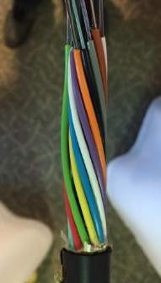
Telecommunication Section
Fig 2.3.21 FOC
Telecommunication section is responsible to transfer the information send by RTU in substation to software section. They responsible about the media that carry information to the software section. There are two types of media that they can send the information through it either wireless or cables. Wireless either by WLAN or GPRS "Etisalat" and that commonly used in AADC because it can send for long distance while cables will be costly for long distance. Cables divide into copper or Fiber Optic cable "FOC" as shown in figure 2.3.21

Software Section

Software section is responsible of receiving signals from RTU then they analyze it and convert them to information that can be understandable and readable. After that, they send this information to control section and it will appear to them on the screen so they follow the following procedures:

          - Front End which mean that the beginning of receiving information from RTU
          - Data Processing include three types :
            - Dual processing : both processor will work together
            - Hot standby: output get it from one processor and the other is just stand by. They will communicate together if the first one not working
            - Cold Standby: they are not in contact if the first one not working the standby will start update and work after 5 minutes

Operation Planning & Studies Department
Operation Planning and study department consists of three sections: 1- Development section
The responsibilities of development section are focusing on the projects, its documents and help project engineer during the period of project especially in the warranty period. Also, they involve in technical evaluation with TMT "Technical management team".
- Operation planning section

Operation planning section will study and review the requests of shutdown electricity in ALAin city with its external regions and they give the approval to contractor or O&M to shutdown electricity to specified place only in addition to that they arrange that all shutdowns should not happen at the same time. They calculate the full load before they transfer the load on the other substations.
- Operation studies section is responsible for :
- Load management by shifting the load.
- Security of supply
- Observe increasing or decreasing in the voltage and reset it if there is changing.
- they the one who close NOP when there is any fault

Network Operation Department

Which include only one section called Control Center Section. This section is the most important section in the NMD because it shows the entire network in ALAin city in the huge screen as shown in figure 2.3.22. Also, it shows the peak load of whole city, frequency and every reading for all substations in ALAin especially primary stations. There are two main screens one of them to the center of ALAin city and the other one for external regions.
Control Center Section divides their work into two units:

  - Planned "for maintenance purpose or operate new project to the network"

  - UN planned "which mean emergency or fault happen to the system


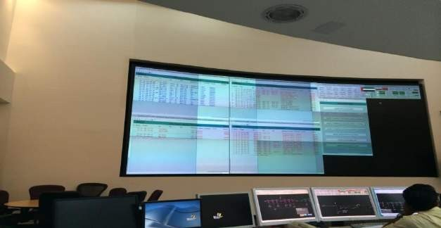
Fig 2.3.22 Control Center Screen
In both unit , any section want to make a shutdown even if its emergency, the section should submit a work request to the HV operation section in O&M department then it will move to operation planning section to review it and finally to the control room. Control engineer will review the request last time and then he will isolate for him.

Chapter Three: Proposal for a Graduation Project

As from the beginning of 2015 there will be an increase in all the prices on elecricity ,After the ADWEA has an approval from executive board. Increasing in the Electricity price for the local will be if his consumption reaches 400 KW and above per month there will be more charge about 5 cents for every one KW while for the residents they will pay production rate for every 1 KW if they reach up to 200KW per month. Most of the people they do not know how much they will consume per a month or if they reach 400 KW to reduce their consumption especially old men and women.
There is already a counter outside in every house that checked by AADC engineers. This defined as electricity meter or energy meter, is a device that measures the amount of electrical energy consumed by homes.
The device I propose is one that gives an alert to the owner that warning him that he will exceed the limit soon. Simply this device like a sensor should be fixed in the main DP of the house "counter". Then it should program to sense at a certain consumption rate according to the customers for example for the locals at 350KW so when the energy meter reaches up to 350KW the sensor will sense this number and direct send a text message to the mobile of the owner "reduce your consumption …….".
There are other equipments which are valid andthat can be added to increase the performance of reduce the consumption such as putting a monitor in the house itself same as monitor in the DMS building of AADC. This monitor do the same purpose of the screen in the DMS which show the consumption rate of this house and customer put this screen in the living room when the consumption rate reach 350KW the color that show the number "load" change to red in the screen. Also, in this screen may have an indication about which room has the most consumption so the customers can reduce the rate before he exceeds the limit.

Chapter Four: Conclusions &Recommendations

In conclusion, the Training course was very relevant to us. It created a link between 4 years of study and experimental work in the field. AADC is among the best place for electric engineers to take the training course with them because their job is to distribute water and electricity to the customers so trainee will see all the steps of electricity's distribution and they will have an idea about transmission & Generation. During 16 weeks of training with them, I moved among two directorates and one division started by Project Delivery Division, Asset Management directorate and Electricity operation and maintains directorate. During the training gained a lot of experience and skills such as what are the basic procedures to do any kind of projects, How to manage the asset and plan for the future in the asset directorate and field experience, see most of the electrical equipments that I never see before, identify the job of each one and how they monitor the whole network of ALAin from one place all of that was taken in electricity operation and maintains directorate and its departments. Finally it was the most enjoyable and helpful course.
- Recommendation:
- For AADC
- I trained around 4 weeks in Asset directorate and form my opinion this period of time is too much because most of their work as management work so if they reduce it to one or two weak
- Send an Email to each department & directorate to inform them about trainees because when we move from directorate to another they ask for official letter or emails from hr.
- Add to the training schedule Customer service directorate because it's too important for trainees to deal direct with customers.
- For UAEU
  - Change submission of the report from Iwill to black bored because Iwill site shutdown every couple of days.
  - Increase number of meeting in the course that is before training course

References

http://www.aadc.ae/en/pages/AboutAADC.aspx

- www.wikipedia.com

- http://emiratestransformer.com/

- http://www.ducab.com/

Some information from the reports that given by AADC engineers


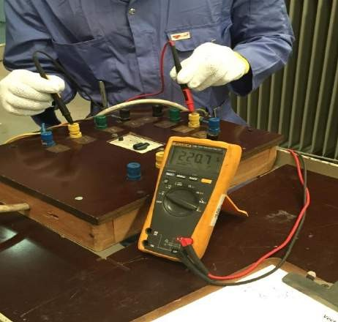
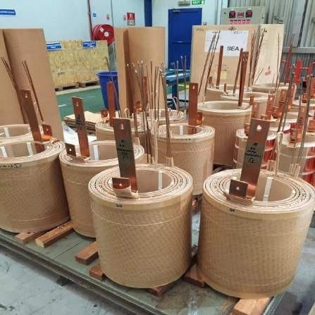
Appendix A (Transformer's Factory)
Fig A.3 measure HV phase with LV phase
Fig A.4 manufacture of TR


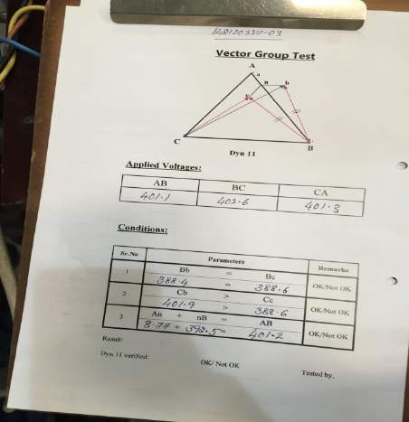

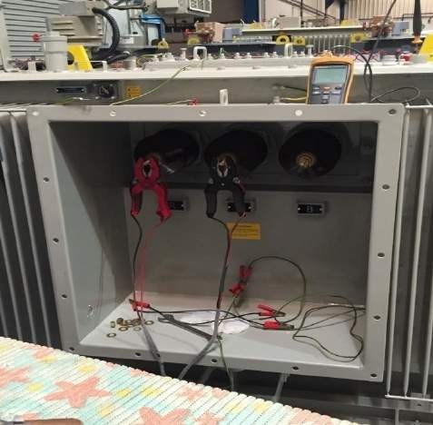
Fig A.1 record measurements
Fig A.2 opens TR from inside

Appendix B (OHL Components)

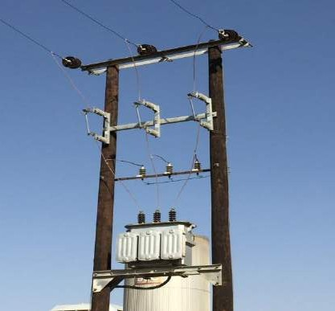


Fig B.1 PMT
Fig B.2 Pin insulator

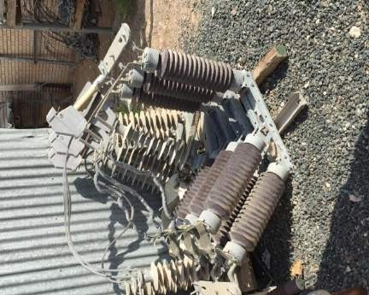
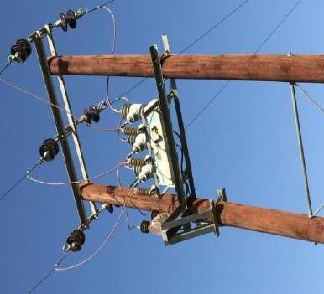
Fig B.3 Master Head switch
Fig B.4 Auto-Recloser

Appendix C (substations equipments)


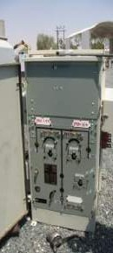

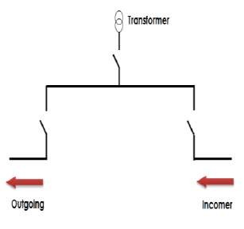

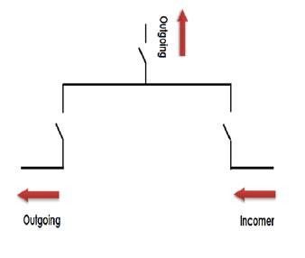

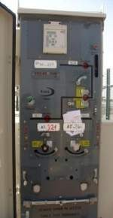

Fig C.1 TRM
Fig C.1 RMU Feeder Type

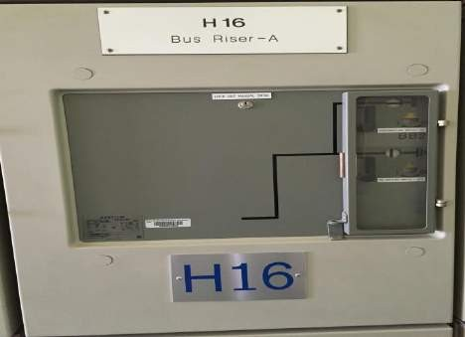
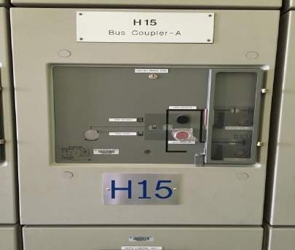

Fig C.3 Bus Riser
Fig C.4 Bus coupler

Appendix D

United Arab Emirates University

College of Engineering - Industrial Training Unit

Industrially Suggested Senior Project

Student Name: Hamad Mohammed Ali ALSaadi Student ID: 201010114

Department: Electrical Engineering Semester & Year: Fall 2014

Company/Organization: AADC

Industrial Supervisor: Dr. Mousa Hussain

Project Description: At the beginning of year 2015 which exactly from 1/1/2015 there will be an increase in the price of electricity after the ADWEA has an approval from executive board. Increasing in the Electricity price for the local will be if his consumption reaches 400 KW and above per month there will be more charge about 5 cents for every one KW while for the residents they will pay production rate for every 1 KW if they reach up to 200KW per month. Most of the people they do not know how much they will consume per a month or if they reach 400 KW to reduce their consumption especially old men and women.
We know that there is already a counter outside in every house that checked by AADC engineers. This defined as electricity meter or energy meter, is a device that measures the amount of electrical energy consumed by homes.
I propose a device that gives an alert to the owner that warning him that he will exceed the limit soon. Simply this device like a sensor should be fixed in the main DP of the house "counter". Then it should program to sense at a certain consumption rate according to the customers for example for the locals at 350KW so when the energy meter reaches up to 350KW the sensor will sense this number and direct send a text message to the mobile of the owner "reduce your consumption …….".
There are other valid equipments that can be added to increase the performance of reduce the consumption such as putting a monitor in the house itself same as monitor in the DMS building of AADC. This monitor do the same purpose of the screen in the DMS which show the consumption rate of this house and customer put this screen in the living room when the consumption rate reach 350KW the color that show the number "load" change to red in the screen. Also, in this screen may have an indication about which room has the most consumption so the customers can reduce the rate before he exceeds the limit.
39

